THE LAST OF US

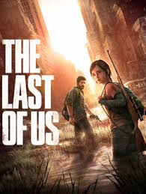The last of Us is a 2013 action-adventure survival horror game developed by naughty dog and published by SONY computer entertainment. Players control Joel, a smuggler who is escorting a teenage girl, Ellie, across a post- apocalyptic United States.

In this game we can see images of an apocalyptic world that transmit despair, panic and confusion. And also, we can see the cities destroyed and demolished. The vegetation takes the control of the places. There’s no more contamination because the human didn’t have the control of the world anymore, and that’s the reason why the water has taken over the cities, which look flooded. We can see the cars that people left, they are rusty and some of them are wrecked. There are no more resources that we usually use. The supermarket food must be contaminated, and the survivors must hunt for survive. No wonder they use weapons for their personal defence, because the situation is hostile.

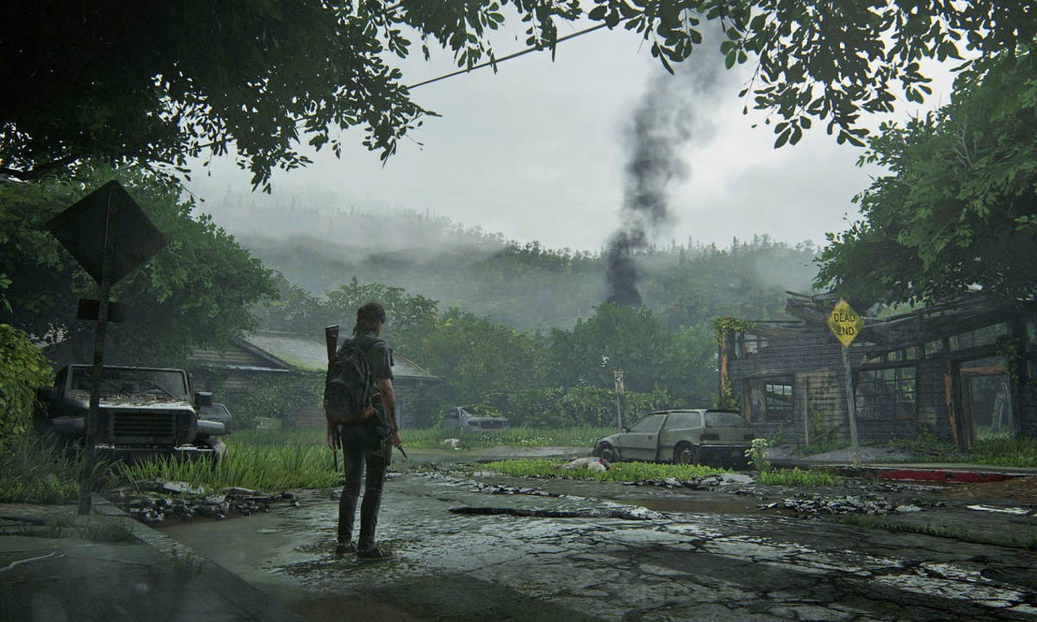Surviving in this situation must be terrible, we cannot imagine what we would do if this happened. These images transmit nostalgia, because I would have a feeling of despair if I saw my house destroyed and know that nothing would be the same again. Although if I tell you the truth, I do not think I would survive in this situation, the zombies would eat me quickly.